Integrantes

Grupo 20  
Cesar Leonel Chamale Sican - 201700634  
Bryan Eduardo Méndez Quevedo - 201801528  
Oscar Daniel Oliva España – 201902663

Sistemas de bases de datos

Proyecto Fase 2

# Proceso de Carga

# Proceso para la creación de los archivos

Se crearon archivos con formato csv, en base a los resultados de las consultas hechas en SQL Server.

Se hizo una colección por cada una de las siguientes consultas:

**PLATFORMDETAIL**

SELECT DISTINCT

p.id AS PlatformID,

p.name AS PlatformName,

p.summary AS PlatformSummary,

p.alternative_name as PlatformAlternativeName,

p.generation as PlatformGeneration,

pf.name as PlatformFamily,

pe.name as PlatformType,

(

select DISTINCT '[' + STRING_AGG( '"'+ platform_version.os+'"' , ', ') +']'

FROM PLATFORM

LEFT JOIN version ON PLATFORM.id = version.id_platform

LEFT JOIN platform_version ON version.id_platform_version = platform_version.id

WHERE PLATFORM.id = p.id

)as PlatformOS,

(

select DISTINCT '[' + STRING_AGG( '"'+ platform_version.memory+'"' , ', ') +']'

FROM PLATFORM

LEFT JOIN version ON PLATFORM.id = version.id_platform

LEFT JOIN platform_version ON version.id_platform_version = platform_version.id

WHERE PLATFORM.id = p.id

)as PlatformMemory,

(

select DISTINCT '[' + STRING_AGG( '"'+ platform_version.graphics+'"' , ', ') +']'

FROM PLATFORM

LEFT JOIN version ON PLATFORM.id = version.id_platform

LEFT JOIN platform_version ON version.id_platform_version = platform_version.id

WHERE PLATFORM.id = p.id

)as Platformgraphics,

(

select DISTINCT '[' + STRING_AGG( '"'+platform_version.online+'"' , ', ') +']'

FROM PLATFORM

LEFT JOIN version ON PLATFORM.id = version.id_platform

LEFT JOIN platform_version ON version.id_platform_version = platform_version.id

WHERE PLATFORM.id = p.id

)as Platformonline,

(

select DISTINCT '[' + STRING_AGG( '"'+ platform_version.resolutions+'"' , ', ') +']'

FROM PLATFORM

LEFT JOIN version ON PLATFORM.id = version.id_platform

LEFT JOIN platform_version ON version.id_platform_version = platform_version.id

WHERE PLATFORM.id = p.id

)as PlatformRes,

(

select DISTINCT '[' + STRING_AGG( '"'+platform_version.resolutions+'"' , ', ') +']'

FROM PLATFORM

LEFT JOIN version ON PLATFORM.id = version.id_platform

LEFT JOIN platform_version ON version.id_platform_version = platform_version.id

WHERE PLATFORM.id = p.id

)as PlatformRes,

(

select DISTINCT '[' + STRING_AGG( '"'+platform_version.cpu+'"' , ', ') +']'

FROM PLATFORM

LEFT JOIN version ON PLATFORM.id = version.id_platform

LEFT JOIN platform_version ON version.id_platform_version = platform_version.id

WHERE PLATFORM.id = p.id

)as PlatformCpu,

(

select DISTINCT '[' + STRING_AGG( '"'+platform_version.storage+'"' , ', ') +']'

FROM PLATFORM

LEFT JOIN version ON PLATFORM.id = version.id_platform

LEFT JOIN platform_version ON version.id_platform_version = platform_version.id

WHERE PLATFORM.id = p.id

)as PlatformStorage,

(

select DISTINCT '[' + STRING_AGG( '"'+platform_version.sound+'"' , ', ') +']'

FROM PLATFORM

LEFT JOIN version ON PLATFORM.id = version.id_platform

LEFT JOIN platform_version ON version.id_platform_version = platform_version.id

WHERE PLATFORM.id = p.id

)as PlatformSound,

(

select DISTINCT '[' + STRING_AGG( '"'+platform_version.Connectivity+'"' , ', ') +']'

FROM PLATFORM

LEFT JOIN version ON PLATFORM.id = version.id_platform

LEFT JOIN platform_version ON version.id_platform_version = platform_version.id

WHERE PLATFORM.id = p.id

)as PlatformConnectivity,

(

select DISTINCT '[' + STRING_AGG( '"'+platform_version.name+'"' , ', ') +']'

FROM PLATFORM

LEFT JOIN version ON PLATFORM.id = version.id_platform

LEFT JOIN platform_version ON version.id_platform_version = platform_version.id

WHERE PLATFORM.id = p.id

)as PlatformVersions,

'[' + STRING_AGG('"'+pvr.human+'"', ', ') +']' AS ReleaseDates,

'[' + STRING_AGG(

CASE WHEN pvc.developer = 1 THEN pvc.company ELSE NULL END, ', '

)+']' AS Developers,

'[' +STRING_AGG(

CASE WHEN pvc.manufacturer = 1 THEN pvc.company ELSE NULL END, ', '

)+']' AS Manufacturers,

(

SELECT DISTINCT

'[' + CAST(STRING_AGG('"'+game.name+'"' , ', ') AS nvarchar(MAX)) +']'

FROM game

WHERE game.id_game IN (

SELECT DISTINCT top 2800 id_game

FROM platform_game

WHERE platform_game.id = p.id

)

)AS PlatformGames

FROM

platform AS p

LEFT JOIN platform_enum as pe ON pe.id = p.platform_enum

LEFT JOIN platform_family as pf ON pf.id = p.platform_family

LEFT JOIN version AS v ON p.id = v.id_platform

LEFT JOIN platform_version AS pv ON v.id_platform_version = pv.id

LEFT JOIN platform_releases AS pr ON pv.id = pr.id_Platform_version

LEFT JOIN platform_version_releasedate AS pvr ON pr.id_Platform_version_releasedate = pvr.id

LEFT JOIN Platform_company as pc on pc.id_Platform_version = pv.id

LEFT JOIN platform_version_company AS pvc ON pc.id_Platform_version_company = pvc.id

GROUP BY p.id, p.name, p.summary, p.alternative_name,p.generation, pf.name, pe.name

;

**RAITINGGAME**

CREATE VIEW Top100Games AS

SELECT

g.id_game as idgame,

g.name AS nombre,

(

SELECT ('['+STRING_AGG('"'+p.name+'"', ', ')+']' )

FROM platform_game AS pg

INNER JOIN platform AS p ON pg.id = p.id

WHERE pg.id_game = g.id_game

) AS plataformas,

g.rating AS rating,

g.aggregated_rating AS valoracion,

(

SELECT '['+STRING_AGG('"'+ge.name+'"', ', ')+']'

FROM genres_game AS gg

INNER JOIN genre AS ge ON gg.id = ge.id

WHERE gg.id_game = g.id_game

) AS generos

FROM game AS g

ORDER BY g.rating DESC, g.aggregated_rating DESC;

**LanguageSupportGame**

WITH GameLanguageDetails AS (

SELECT

ls.id_game,

l.name AS LanguageName,

ls.language_support_type,

CASE

WHEN ls.language_support_type = 1 THEN 'Audio'

WHEN ls.language_support_type = 2 THEN 'Subtitles'

WHEN ls.language_support_type = 3 THEN 'Interface'

END AS SupportType

FROM

language_support ls

JOIN language l ON ls.id_language = l.id

),

ConsolidatedLanguageDetails AS (

SELECT

gld.id_game,

gld.LanguageName,

-- Preparando el string en un formato que puede ser convertido en JSON

CONCAT('[',

STRING_AGG(

CONCAT(

'{"supportType":"',

gld.SupportType,

'"}'

),

','

) WITHIN GROUP (ORDER BY gld.SupportType),

']') AS LanguageSupportJSON

FROM

GameLanguageDetails gld

GROUP BY

gld.id_game,

gld.LanguageName

),

FinalLanguageDetails AS (

SELECT

id_game,

-- Concatenando todos los objetos JSON de idiomas en un array JSON

CONCAT(

'[',

STRING_AGG(

CONCAT(

'{"languageName":"',

LanguageName,

'", "supports":',

LanguageSupportJSON,

'}'

),

','

) WITHIN GROUP (ORDER BY LanguageName),

']'

) AS LanguageSupportDetails

FROM

ConsolidatedLanguageDetails

GROUP BY

id_game

),

GameRatings AS (

SELECT

g.id_game,

g.name,

g.rating,

ROW_NUMBER() OVER(ORDER BY g.rating DESC, g.name) as rn -- Agregamos numeración basada en la calificación

FROM

game g

)

-- Consulta final para obtener los resultados deseados

SELECT

gr.id_game,

gr.name,

gr.rating,

fld.LanguageSupportDetails

FROM

GameRatings gr

JOIN FinalLanguageDetails fld ON gr.id_game = fld.id_game

WHERE

gr.rn <= 300000 -- Filtramos para mantener solo el top 10

ORDER BY

gr.rating DESC, gr.name;

**GenresViewPlatform**

WITH GenreData AS (

SELECT

g.id_game,

g.name AS game_name,

'[' + STRING_AGG(

CONCAT(

'{"id_genre": ',

CAST(gen.id AS NVARCHAR(MAX)),

', "genre": "',

gen.name,

'"}'

),

', '

) + ']' AS aggregated_genres

FROM

game g

JOIN

genres_game gg ON g.id_game = gg.id_game

JOIN

genre gen ON gg.id = gen.id

GROUP BY

g.id_game, g.name

),

-- CTE para los datos de plataforma

PlatformData AS (

SELECT

g.id_game,

g.name AS game_name,

'[' + STRING_AGG(

CONCAT(

'{"id_platform": ',

CAST(pl.id AS NVARCHAR(MAX)), -- Convertir a texto para la concatenación

', "platform": "',

pl.name,

'"}'

),

', '

) + ']' AS aggregated_platforms

FROM

game g

JOIN

platform_game plg ON g.id_game = plg.id_game

JOIN

platform pl ON plg.id = pl.id

GROUP BY

g.id_game, g.name

),

-- CTE para los datos de calificación máxima

MaxRatingData AS (

SELECT

g.id_game,

MAX(g.rating) AS max_rating

FROM

game g

GROUP BY

g.id_game

)

-- Consulta principal para combinar resultados

SELECT

gd.id_game AS GameID,

gd.game_name AS GameName,

gd.aggregated_genres AS Genres,

pd.aggregated_platforms AS Platforms,

mrd.max_rating AS MaxRating

FROM

GenreData gd

JOIN

PlatformData pd ON gd.id_game = pd.id_game

JOIN

MaxRatingData mrd ON gd.id_game = mrd.id_game

ORDER BY

mrd.max_rating DESC;

**ULTIMA**

CREATE PROCEDURE AMONGO2

@Inicio INT,

@Fin INT

AS

BEGIN

WITH Subquery1 AS (

SELECT DISTINCT

g.name AS JUEGO,

g.first_release_date AS Primera_Fecha_Lanzamiento,

g.summary AS Descripcion,

g.rating AS Puntaje,

g.aggregated_rating AS Puntaje_de_Critica,

g.local_rating AS Puntaje_Total,

g.storyline AS Sinopsis,

g.id_game AS ID_Juego

FROM game AS g

WHERE g.id_game>= @Inicio

AND g.id_game<= @Fin

GROUP BY

g.name, g.first_release_date, g.summary, g.rating, g.aggregated_rating, g.local_rating, g.storyline, g.id_game

),

Subquery2 AS (

SELECT DISTINCT

g.id_game,

'['+ STRING_AGG(

CONCAT(

'{"Id":'+ CAST(genre.id AS NVARCHAR(MAX))+',',

' "Name": "'+genre.name+'",',

' "Url": "'+genre.url+'"}'

)

, ',')+']' AS Genero

FROM game AS g

LEFT JOIN genres_game AS gg ON gg.id_game = g.id_game

LEFT JOIN genre ON gg.id = genre.id

WHERE g.id_game>= @Inicio

AND g.id_game<= @Fin

GROUP BY g.id_game

),

Subquery3 AS (

SELECT DISTINCT

g.id_game,

'['+ STRING_AGG('{'+

CONCAT(

'"Id":'+CAST(p.id AS NVARCHAR(MAX))+',',

' "Name": "'+p.name+'",',

' "Abbreviation": "'+p.abbreviation+'",',

' "Alternative_Name": "'+p.alternative_name+'",',

' "Generation": "'+p.generation+'",',

' "Summary": "'+p.summary+'",',

' "Url": "'+p.url+'"}'

)

, ',') +']' AS Plataforma

FROM game AS g

LEFT JOIN platform_game AS pg ON pg.id_game = g.id_game

LEFT JOIN platform AS p ON p.id = pg.id

WHERE g.id_game>= @Inicio

AND g.id_game<= @Fin

GROUP BY g.id_game

),

Subquery4 AS (

SELECT

g.id_game,

'['+STRING_AGG(

ISNULL(

CONCAT(

ISNULL('{"Plataforma":"'+p.name+'",','{'),

ISNULL('"Fecha":"'+rd.human+'",',''),

ISNULL('"Region":'+

CASE

WHEN rd.region= 1 THEN '"europe"}'

WHEN rd.region = 2 THEN '"north_america"}'

WHEN rd.region = 3 THEN '"australia"}'

WHEN rd.region = 4 THEN '"new_zealand"}'

WHEN rd.region = 5 THEN '"japan"}'

WHEN rd.region = 6 THEN '"china"}'

WHEN rd.region = 7 THEN '"asia"}'

WHEN rd.region = 8 THEN '"worldwide"}'

WHEN rd.region = 9 THEN '"korea"}'

WHEN rd.region = 10 THEN '"brazil"}'

END

,'}')

)

,'')

,',')+']' AS Release

FROM game AS g

LEFT JOIN release_date AS rd ON rd.id_game = g.id_game

LEFT JOIN platform AS p ON p.id = rd.platform

WHERE g.id_game>= @Inicio

AND g.id_game<= @Fin

GROUP BY g.id_game

),

Subquery5 AS (

SELECT DISTINCT

g.id_game,

(

SELECT

'['+ STRING_AGG(

CONCAT(

'{"Id":'+ CAST(c.id AS NVARCHAR(MAX))+',',

' "Name": "'+c.name+'",',

' "Country": "'+c.country+'",',

' "Summary": "'+c.description+'",',

' "Start_Date": "'+CAST(c.start_date AS NVARCHAR(MAX))+'"}'

)

, ', ') + ']' AS Developer

FROM involved_company AS ic

LEFT JOIN company AS c ON c.id = ic.company

WHERE g.id_game = ic.game

AND ic.developer = 'true'

) AS Developer,

(

SELECT '['+ STRING_AGG(

CONCAT(

'{"Id":'+ CAST(c.id AS NVARCHAR(MAX))+',',

' "Name": "'+c.name+'",',

' "Country": "'+c.country+'",',

' "Summary": "'+c.description+'",',

' "Start_Date": "'+CAST(c.start_date AS NVARCHAR(MAX))+'"}'

)

, ', ') + ']' AS Publisher

FROM involved_company AS ic

LEFT JOIN company AS c ON c.id = ic.company

WHERE g.id_game = ic.game

AND ic.publisher = 'true'

) AS Publisher,

(

SELECT '['+ STRING_AGG(

CONCAT(

'{"Id":'+ CAST(c.id AS NVARCHAR(MAX))+',',

' "Name": "'+c.name+'",',

' "Country": "'+c.country+'",',

' "Summary": "'+c.description+'",',

' "Start_Date": "'+CAST(c.start_date AS NVARCHAR(MAX))+'"}'

)

, ', ') + ']' AS Porting

FROM involved_company AS ic

LEFT JOIN company AS c ON c.id = ic.company

WHERE g.id_game = ic.game

AND ic.porting = 'true'

) AS Porting,

(

SELECT '['+ STRING_AGG(

CONCAT(

'{"Id":'+ CAST(c.id AS NVARCHAR(MAX))+',',

' "Name": "'+c.name+'",',

' "Country": "'+c.country+'",',

' "Summary": "'+c.description+'",',

' "Start_Date": "'+CAST(c.start_date AS NVARCHAR(MAX))+'"}'

)

, ', ') + ']' AS Supporting

FROM involved_company AS ic

LEFT JOIN company AS c ON c.id = ic.company

WHERE g.id_game = ic.game

AND ic.supporting = 'true'

) AS Supporting

FROM game AS g

WHERE g.id_game>= @Inicio

AND g.id_game<= @Fin

),

Subquery6 AS (

SELECT DISTINCT

g.id_game,

'['+ STRING_AGG(

CONCAT(

'{"Id":'+ CAST(gm.id AS NVARCHAR(MAX))+',',

' "Name": "'+gm.name+'",',

' "Url": "'+gm.url+'"}'

)

, ', ')+']' AS Modo_Juego

FROM game AS g

LEFT JOIN game_mode_game AS gmg ON gmg.id_game = g.id_game

LEFT JOIN game_mode AS gm ON gm.id = gmg.id

WHERE g.id_game>= @Inicio

AND g.id_game<= @Fin

GROUP BY g.id_game

),

Subquery7 AS (

SELECT DISTINCT

g.id_game,

'['+STRING_AGG(

CONCAT(

'{"Id":'+ CAST(t.id AS NVARCHAR(MAX))+',',

' "Name": "'+t.name+'",',

' "Url": "'+t.url+'"}'

)

, ', ')+']' AS Theme

FROM game AS g

LEFT JOIN themes_game AS tg ON tg.id_game = g.id_game

LEFT JOIN theme AS t ON t.id = tg.id

WHERE g.id_game>= @Inicio

AND g.id_game<= @Fin

GROUP BY g.id_game

),

Subquery8 AS (

SELECT DISTINCT

g.id_game,

'['+STRING_AGG(

CONCAT(

'{"Id":'+ CAST(c.id AS NVARCHAR(MAX))+',',

' "Name": "'+c.name+'",',

' "Url": "'+c.url+'"}'

)

, ', ')+']' AS Series

FROM game AS g

LEFT JOIN collections AS c ON c.id= g.collections

WHERE g.id_game>= @Inicio

AND g.id_game<= @Fin

GROUP BY g.id_game

),

Subquery9 AS (

SELECT DISTINCT

g.id_game,

'['+STRING_AGG(

CONCAT(

'{"Id":'+ CAST(pp.id AS NVARCHAR(MAX))+',',

' "Name": "'+pp.name+'",',

' "Url": "'+pp.url+'"}'

)

, ', ')+']' AS Player_Perspective

FROM game AS g

LEFT JOIN player_perspective_game AS ppg ON ppg.id_game= g.id_game

LEFT JOIN player_perspective AS pp ON pp.id = ppg.id

WHERE g.id_game>= @Inicio

AND g.id_game<= @Fin

GROUP BY g.id_game

),

Subquery10 AS (

SELECT DISTINCT

g.id_game,

'['+STRING_AGG(

CONCAT(

'{"Id":'+ CAST(f.id AS NVARCHAR(MAX))+',',

' "Name": "'+f.name+'",',

' "Url": "'+f.url+'"}'

)

, ', ')+']' AS Franchise

FROM game AS g

LEFT JOIN franchise_game AS fg ON fg.id_game= g.id_game

LEFT JOIN franchise AS f ON f.id = fg.id

WHERE g.id_game>= @Inicio

AND g.id_game<= @Fin

GROUP BY g.id_game

),

Subquery11 AS (

SELECT DISTINCT

g.id_game,

'['+STRING_AGG(

CONCAT(

'{"Id":'+ CAST(r.id AS NVARCHAR(MAX))+',',

' "Name": "'+r.nombre+'",',

' "Identifier": "'+r.identifier+'"}'

)

, ',')+']' AS Region,

'['+STRING_AGG(

CONCAT(

'{"Id":'+ CAST(gl.id AS NVARCHAR(MAX))+',',

' "Name": "'+gl.name+'"}'

)

, ',')+']' AS Localized_Titles

FROM game AS g

LEFT JOIN game_localization AS gl ON gl.id_game = g.id_game

LEFT JOIN region AS r ON r.id = gl.id_region

WHERE g.id_game>= @Inicio

AND g.id_game<= @Fin

GROUP BY g.id_game

),

Subquery12 AS (

SELECT DISTINCT

g.id_game,

'['+STRING_AGG(

CONCAT(

'{"Id":'+ CAST(an.id AS NVARCHAR(MAX))+',',

'"Comment": "'+an.comment+ '",',

'"Alternative_Name":"'+an.name+'"}'

)

, ', ')+']' AS XAlternative_name

FROM game AS g

LEFT JOIN alternative_name AS an ON an.id_game = g.id_game

WHERE g.id_game>= @Inicio

AND g.id_game<= @Fin

GROUP BY g.id_game

),

MainQuery AS (

SELECT DISTINCT

S1.JUEGO,

S1.Primera_Fecha_Lanzamiento,

S2.Genero,

S3.Plataforma,

S1.Descripcion,

S1.Puntaje,

S1.Puntaje_de_Critica,

S1.Puntaje_Total,

S1.Sinopsis,

S1.ID_Juego,

S4.Release,

S5.Developer,

S5.Publisher,

S5.Porting,

S5.Supporting,

S6.Modo_Juego,

S7.Theme,

S8.Series,

S10.Franchise,

S9.Player_Perspective,

S11.Region,

S11.Localized_Titles,

S12.XAlternative_name

FROM Subquery1 S1

LEFT JOIN Subquery2 S2 ON S1.ID_Juego = S2.id_game

LEFT JOIN Subquery3 S3 ON S3.id_game= S1.ID_Juego

LEFT JOIN Subquery4 S4 ON S4.id_game = S1.ID_Juego

LEFT JOIN Subquery5 S5 ON S5.id_game = S1.ID_Juego

LEFT JOIN Subquery6 S6 ON S6.id_game = S1.ID_Juego

LEFT JOIN Subquery7 S7 ON S7.id_game = S1.ID_Juego

LEFT JOIN Subquery8 S8 ON S8.id_game = S1.ID_Juego

LEFT JOIN Subquery9 S9 ON S9.id_game = S1.ID_Juego

LEFT JOIN Subquery10 S10 ON S10.id_game = S1.ID_Juego

LEFT JOIN Subquery11 S11 ON S11.id_game = S1.ID_Juego

LEFT JOIN Subquery12 S12 ON S12.id_game = S1.ID_Juego

)

SELECT DISTINCT

g.JUEGO,

g.Primera_Fecha_Lanzamiento,

g.Genero,

g.Plataforma,

g.Descripcion,

g.Puntaje,

g.Puntaje_de_Critica,

g.Puntaje_Total,

g.Sinopsis,

g.ID_Juego,

g.Release,

g.Developer,

g.Publisher,

g.Porting,

g.Supporting,

g.Modo_Juego,

g.Genero,

g.Theme,

g.Series,

g.Franchise,

g.Player_Perspective,

g.Region,

g.Localized_Titles,

g.XAlternative_name

FROM MainQuery g

ORDER BY g.ID_Juego

END;

# Proceso de Carga

# Creación de archivos

Se ejecuta la consulta y retorna un resultado en la consola

Se realiza clic derecho al resultado y se selecciona la opción “Save Result As.”, con el que posteriormente lo guardaremos en el lugarque querramos, en formato “csv”.

# Inserción de datos

Se crea una base de datos, en este caso se llamará “gamestwitch”



Luego de creada la base de datos, se crean las colecciones, en este caso se llamrá “genreViewPlatform”

En el IDE de mongoDB, Mongo Compass, se selecciona la opción “Import Data” , y seleccionamos el archivo “csv” que queramos ingresar.

* Cabe resaltar que al csv se le deben de agregar los encabezados

El propio IDE intentará, automáticamente, agregar los tipos de dato a los valores, en base a los datos del resultado de la consulta.

Luego se selecciona “import” para que se empiecen a ingresar los datos.

Al finalizar de ingresar los datos, los mismos se mostrarán ya ingresados de la siguiente manera

Para poder verlos en formato json, se deberá de presionar el botón del lado derecho con la figura de llaves abiertas y cerradas “{}”

# Modelos No-SQL

## PlatformDetails

## GenreViewPlatform

## LanguageSupportGame

RatingGame

## Ultima

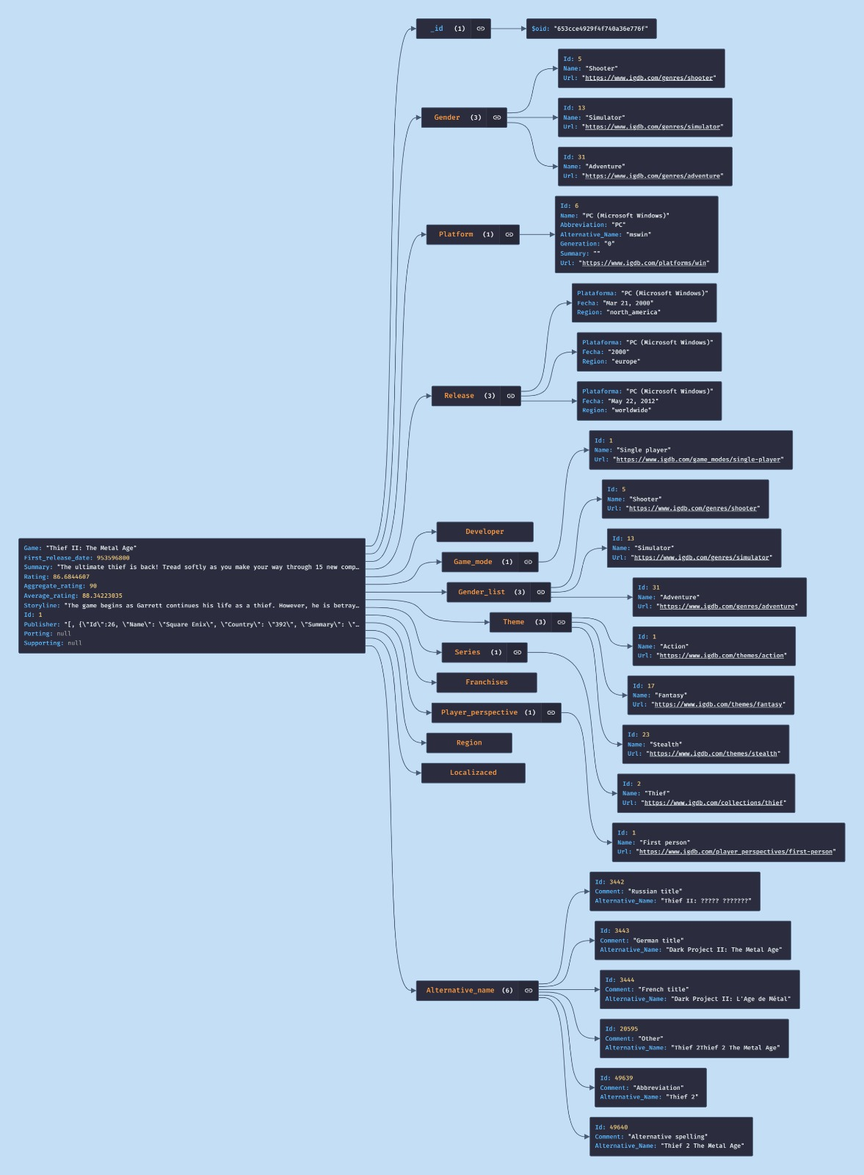

# Consultas

## Consulta General - Información de Juego

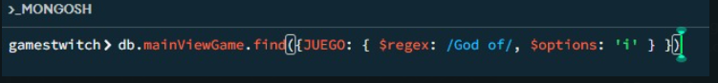

db.mainViewGame.find({JUEGO: { $regex: /God of/, $options: 'i' } })

## Consulta 1 – Top 100 por rating

db.ratingGame.aggregate([

{

$sort: {

valoracion: -1

}

},

{

$limit: 100

},

{

$project: {

_id: 0,

rating: 1,

nombre: 1,

generos: 1,

plataformas: 1,

valoracion: 1

}

}

])

## Consulta 2 – Buscar juego por nombre

db..find({Game: { $regex: / name /, $options: 'i' } })

## Consulta 3 - Información de Juego Agrupado por Plataforma

db.ultima.aggregate([

{

$match: {

Game: {$regex: /God of/, $options: 'i' }

}

},

{

$group: {

_id: "$Platform",

count: { $sum: 1 }

}

}

])

## Consulta 4 – Conteo de soportes de lenguaje

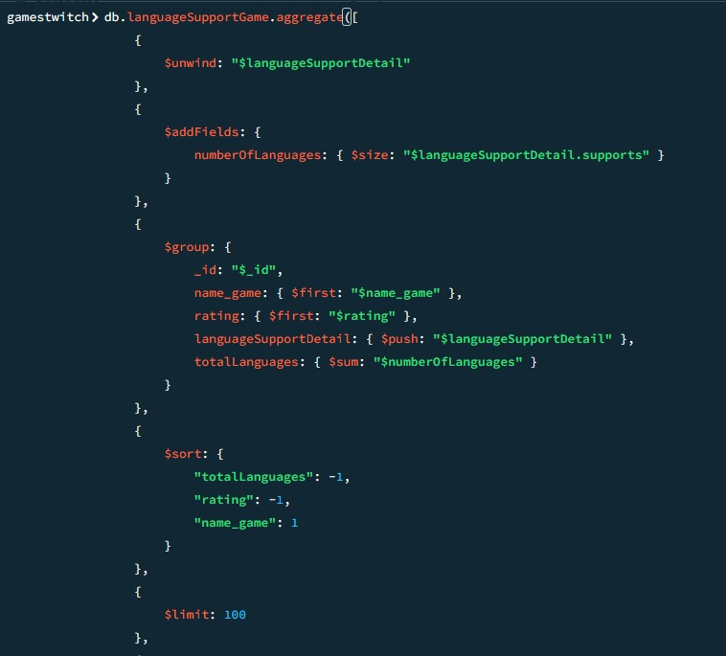

db.languageSupportGame.aggregate([

{

$unwind: "$languageSupportDetail"

},

{

$addFields: {

numberOfLanguages: { $size: "$languageSupportDetail.supports" }

}

},

{

$group: {

_id: "$_id",

name_game: { $first: "$name_game" },

rating: { $first: "$rating" },

languageSupportDetail: { $push: "$languageSupportDetail" },

totalLanguages: { $sum: "$numberOfLanguages" }

}

},

{

$sort: {

"totalLanguages": -1,

"rating": -1,

"name_game": 1

}

},

{

$limit: 100

},

{

$project: {

_id: 1,

name_game: 1,

rating: 1,

supportedLanguages: "$languageSupportDetail.languageName",

supports: "$languageSupportDetail.supports",

totalLanguages: 1

}

}

])

## Consulta 5 – Top Juegos por género y plataformas ordenados por rating

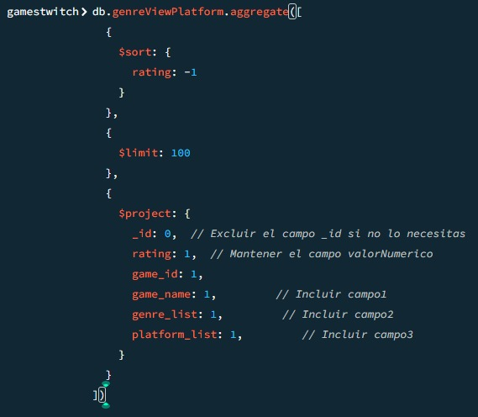

db.genreViewPlatform.aggregate([

{

$sort: {

rating: -1

}

},

{

$limit: 100

},

{

$project: {

_id: 0, // Excluir el campo _id si no lo necesitas

rating: 1, // Mantener el campo valorNumerico

game_id: 1,

game_name: 1, // Incluir campo1

genre_list: 1, // Incluir campo2

platform_list: 1, // Incluir campo3

}

}

])

## Consulta Plataforma – Plataforma

db.platformDetail.find({PlatformName: {$regex: /Xbox/, $options: ‘I’} })

# Base de Datos SQL

## Troncamiento de bitácora

Se hace un troncamiento a la bitácora, para desechar la data, o el cache, que ya no nos sirve, para liberar espacio.

Ya que la base de datos está en la nube, específicamente en Amazon RDS, no se pudieron hacer Backups o troncamientos, ya que se necesita la dirección física, pero sí se pudieron realizar snapshots, que es una copia de seguridad de la instancia de la base de datos, con todos sus datos, incluidos sus configuraciones, al momento de hacer el mismo.

## Collation

Los collation son las reglas de cómo se comparan y determinan los datos de cada texto, por lo que solo los atributos que sean de tipo “STRING” tendrán este campo con alguna definición.

Se utilizó el siguiente comando, con cada tabla, para saber cuál era el collation de cada uno.

SELECT TABLE_NAME, COLUMN_NAME, COLLATION_NAME FROM INFORMATION_SCHEMA.COLUMNS WHERE TABLE_NAME = ‘game’

## Fragmentación de Ïndices

Se mostrará lo fragmentado que están los índices de las tablas, junto con cuales son sus índices.

Se utilizó el siguiente comando para ver el estado de los mismos, en cada tabla.

SELECT

OBJECT_NAME(ips.[object_id]) AS TableName,

i.name AS IndexName,

i.type_desc AS IndexDescription,

STUFF((SELECT ', ' + c.name

FROM sys.index_columns ic

INNER JOIN sys.columns c ON ic.object_id = c.object_id AND ic.column_id = c.column_id

WHERE ic.object_id = ips.[object_id] AND ic.index_id = i.index_id -- Corregido aquí

FOR XML PATH('')), 1, 2, '') AS IndexKeys,

ps.avg_fragmentation_in_percent

FROM sys.dm_db_index_physical_stats(DB_ID(), NULL, NULL, NULL, NULL) ps

INNER JOIN sys.indexes i ON ps.[object_id] = i.[object_id] AND ps.index_id = i.index_id

INNER JOIN sys.objects ips ON ps.[object_id] = ips.[object_id]

WHERE ips.type = 'U';

## Reducción de fragmentación

Se utilizó el siguiente comando para disminuir la fragmentación de los índices de las tablas.

